A000-ME-UR-Cylinder Seal-Ur_Nammu-Contest of Sumer and Agade-Clay-2100-2050 BCE





Figs. 1-2.

**Case no.: 2**

**Accession Number:**

**Formal Label:**

**Display Description:**

This is an Ur III period cylinder seal impression that was made from a lost cylinder seal (probably of serpentine or steatite during this period) dating to the rule of the first king of Ur III Ur-Nammu who may be the one of the figures shown in a contest between lions and wild bulls.

Ur-Nammu who was a general and perhaps governor of Ur succeeded to the throne after Utu-Hengal, the ruler of Uruk, who had expelled war-like Gutians who had invaded from the Zagros mountains to the east after their rule spanning a period of 25 to 124 years (based on contradictory records). Ur-Nammu displayed his military prowess after being ruler of Ur for only four years when he deposed the ruler of Agade and henceforth was known as the ruler of both cities. Ur-nammu’s prowess may be the subject of this cylinder seal impression which may characterize his rule over his two cities metaphorically as Sumer, the lion, and Agade, the wild bull. Ur's dominance over these cities expanded to include a Neo-Sumerian Empire which was consolidated with Ur-Nammu’s legal code, 2100–2050 BCE, the earliest extant law code surviving.

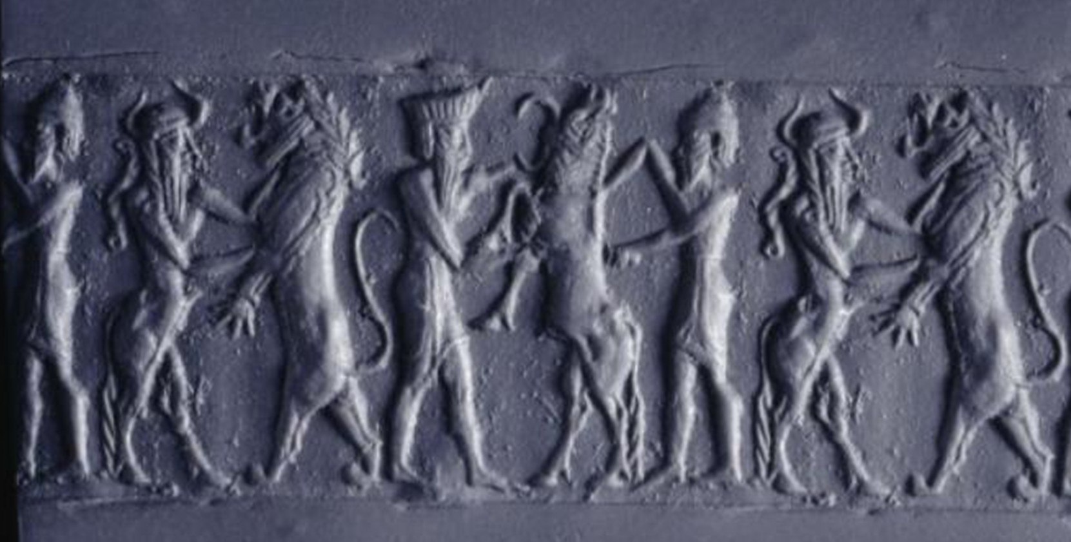***Figure 3: Modern impression of a lapis lazuli cylinder seal with original gold ornamental caps from the Royal Cemetery at Ur (2200-2100 BCE); BM 121547 © Trustees of the British Museum***

**This cylinder seal impression of a standard contest between helmeted shamans and their spiritual animal counterparts – lions and bulls -- in a scene similar to the one under examination.**

**LC Classification:**

**Date or Time Horizon:**

**Geographical Area:**

**Map:**

**GPS coordinates:**

**Cultural Affiliation:**

**Media:**

**Dimensions:**

**Weight:**

**Condition:**

**Provenance:**

**Discussion:**

**References:**